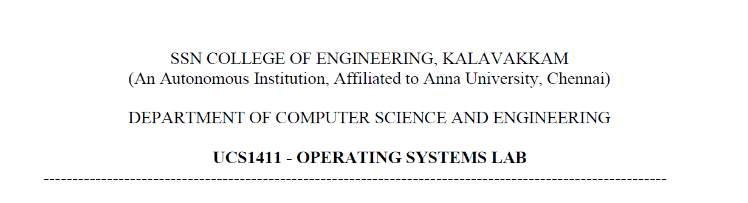

**NETWORKS LAB**

**EXERCISE 6**

Name: Jayannthan P T

Dept: CSE ‘A’

Roll No.: 205001049

Computing Hamming code for Error correction

**Aim:**

To implement Hamming Code for Single Error Correction using C socket program

**Algorithm:**

**SERVER**

Establish TCP/IP connection from server to client

1. Read the input from a user (zero's and one's)

* 1. 2. Encoding a message by Hamming Code

a. Calculate the number of redundant bits.

b. Position the redundant bits.

c. Calculate the values of each redundant bit.

* 1. 3. Introduce error (single bit error or no error)
  2. 4. Send the data to receiver

**CLIENT**

Establish TCP/IP connection from server to client

1. Receive the data from the sender and.

* 1. 2. Check for any error by performing the following operations

a. Calculation of the number of redundant bits.

b. Positioning the redundant bits.

c. Parity checking.

d. If any error, correct the error and display the original message.

**Code:**

**Server**

#include<stdio.h>

#include<stdlib.h>

#include<time.h>

#include<sys/types.h>

#include<sys/socket.h>

#include<netinet/in.h>

#include<stdlib.h>

#include<string.h>

#include<unistd.h>

#include<arpa/inet.h>

#include<fcntl.h>

#include<stdbool.h>

#include<math.h>

#define MAXSIZE 1024

**int** binary(**int** num)

{

**int** bin = 0, r;

**int** i = 0;

    while(num > 0)

    {

        r = num % 2;

        bin += r * pow(10, i);

        num /= 2;

        i++;

    }

    return bin;

}

**int** ispresent(**int** num,**int** pos)

{

**int** rem;

    for(**int** i = 0; i < pos; i++)

    {

        rem = num % 10;

        num = num / 10;

    }

    if(rem == 1)

    {

        return 1;

    }

    else

    {

        return 0;

    }

}

**int** isapower2(**int** n)

{

    if(ceil(log2(n)) == floor(log2(n)))

    {

        return 1;

    }

    else

    {

        return 0;

    }

}

**int** main(**int** argc, **char** ** argv)

{

    srand(time(NULL));

    if (argc < 2){

        fprintf(stderr, "Enter port number as argument!\n");

        exit(EXIT_FAILURE);

    }

**int** PORT = atoi(argv[1]);

**int** sockfd, newfd, n, arr[30];

**char** buff[MAXSIZE], buffer[MAXSIZE], data_t[40];

**long** data;

**struct** sockaddr_in servaddr,clientaddr;

    if((sockfd = socket(AF_INET, SOCK_STREAM, 0)) < 0)

    {

        perror("Socket creation failed!");

        exit(1);

    }

    bzero(&servaddr,sizeof(servaddr));

    servaddr.sin_family = AF_INET; *// IPv4*

    servaddr.sin_addr.s_addr = INADDR_ANY;

    servaddr.sin_port = htons(PORT);

    if(bind(sockfd, (**const** **struct** sockaddr *)&servaddr,sizeof(servaddr)) < 0)

    {

        perror("Bind failed!");

        exit(1);

    }

    listen(sockfd, 2);

    printf("Enter the data to send: ");

    scanf("%lu", &data);

**long** num =data,count = 0;

    while(num > 0)

    {

        num = num / 10;

        count++;

    }

    n=count;

**int** r=1;

*//r = log2(n);*

*//r = floor(r);*

*// Finding number of redundant bits*

    while(pow(2, r) < n + r + 1)

    {

        r += 1;

    }

**int** total = n + r;

    printf("\nNo. of redundant bits : %d\nTotal no. of bits:%d\n", r,total);

*//nob = floor(log2(total));*

*//creating spaces for redundant bits*

    for(**int** i = 1; i <= total; i++)

    {

**int** digit = data % 10;

        if(isapower2(i) == 0)

        {

            arr[total - i] = digit;

            data /= 10;

        }

        else

        {

            arr[total-i]=0;

        }

    }

*//assigning redundant bits*

    for(**int** i = 0; i < r; i++)

    {

        for(**int** j = 1; j <= total; j++)

        {

            if((**int**)(pow(2, i)) != j)

            {

**int** bin = binary(j);

                if(ispresent(bin, i + 1))

                    count += arr[total - j];

            }

        }

        if(count % 2 == 0)

            arr[total - (**int**)(pow(2, i))] = 0;

        else

            arr[total - (**int**)(pow(2, i))] = 1;

        count = 0;

    }

    printf("\nData with redundant bits: ");

    for(**int** i = 0; i < total; i++)

    {

        printf("%d", arr[i]);

    }

*// printf("\nEnter error position: ");*

*// scanf("%d", &pos);*

**int** pos = rand() % total + 1;

    printf("\nIntroducing error randomly at bit: %d\n", pos);

    if(arr[total - pos] == 0)

    {

        arr[total - pos] = 1;

    }

    else

    {

        arr[total - pos] = 0;

    }

**int** k = 0;

    num = 0;

    for(**int** i = total - 1; i >= 0; i--)

    {

        num += pow(10, k) * arr[i];

        k++;

    }

    sprintf(data_t, "%lu", num);

    printf("Data transmitted is %s\n", data_t);

**int** len = sizeof(clientaddr);

    newfd = accept(sockfd, (**struct** sockaddr*)&clientaddr, &len);

**int** m = write(newfd, data_t, sizeof(data_t));

}

**Client**

#include<stdio.h>

#include<sys/types.h>

#include<sys/socket.h>

#include<netinet/in.h>

#include<string.h>

#include<unistd.h>

#include<arpa/inet.h>

#include<stdlib.h>

#include<math.h>

#define MAXLINE 1024

**int** countbits(**long** num)

{

**int** r, count = 0;

    while(num > 0)

    {

        num = num / 10;

        count++;

    }

    return count;

}

**int** binary(**int** num)

{

**int** bin = 0, r;

**int** i = 0;

    while(num > 0)

    {

        r = num % 2;

        bin += r * pow(10, i);

        num /= 2;

        i++;

    }

    return bin;

}

**int** ispresent(**int** num,**int** pos)

{

**int** rem;

    for(**int** i = 0; i < pos; i++)

    {

        rem = num % 10;

        num = num / 10;

    }

    if(rem == 1)

    {

        return 1;

    }

    else

    {

        return 0;

    }

}

**int** decimal(**int** num)

{

**int** rem, i = 0, result;

    while(num > 0)

    {

        rem = num % 10;

        result += pow(2, i) * rem;

        num /= 10;

        i++;

    }

    return result;

}

**int** main(**int** argc, **char** **argv)

{

    if (argc < 2){

        fprintf(stderr, "Please enter port number as second argument!\n");

        exit(EXIT_FAILURE);

    }

**int** PORT = atoi(argv[1]);

**long** num;

**int** sockfd, arr[20], newarr[20], finalarr[20];

**char** buffer1[40];**int** binary(**int** num)

{

**int** bin = 0, r;

**int** i = 0;

    while(num > 0)

    {

        r = num % 2;

        bin += r * pow(10, i);

        num /= 2;

        i++;

    }

    return bin;

}

**struct** sockaddr_in servaddr;

    if ((sockfd = socket(AF_INET, SOCK_STREAM, 0)) < 0) {

        perror("Socket creation failed!");

        exit(1);

    }

    bzero(&servaddr,sizeof(servaddr));

    servaddr.sin_family = AF_INET;

    servaddr.sin_port = htons(PORT);

    servaddr.sin_addr.s_addr = inet_addr("127.0.0.1");

**int** n, len;

    connect(sockfd, (**struct** sockaddr*)&servaddr, sizeof(servaddr));

    n = read(sockfd, buffer1, sizeof(buffer1));

    num = atol(buffer1);

**int** count = 0;

**long** num1=num;

    while(num1 > 0)

    {

        num1 = num1 / 10;

        count++;

    }

**int** total = count;

    printf("Received data: %lu\nTotal bits:%d\n", num,total);

**int** i = 1;

    while(num > 0)

    {

**int** rem = num % 10;

        arr[total - i] = rem;

        num /= 10;

        i++;

    }

*//calculationg number of redundant bits*

**int** r=0;

    for(i = 1; i <= total; i++)

    {

        if(ceil(log2(i)) == floor(log2(i)))

        {

            r++;

        }

    }

*//checking parity of redundant bits*

**int** result=0,k = 0;

    for(i = 0; i < 4; i++)

    {

        for(**int** j = 1; j <= total; j++)

        {

**int** bin = binary(j);

            if(ispresent(bin, i + 1))

            {

                count += arr[total - j];

            }

        }

        if(count % 2 == 0)

        {

            result += pow(10, k) * 0;

        }

        else

        {

            result += pow(10, k) * 1;

        }

        k++;

        count=0;

    }

**int** error = decimal(result);

    printf("\nError bit in binary: %d\n", result);

    printf("\nError in bit in decimal %d\n", error);

*//error correction at error bit*

    if(arr[total - error] == 0)

    {

        arr[total - error] = 1;

    }

    else

    {

        arr[total - error] = 0;

    }

    printf("\nMessage after error correction: ");

    for(i = 0; i < total; i++)

    {

        printf("%d", arr[i]);

    }

    printf("\n");

*//shifting bits to its position*

    k = 0;

    for(i = total - 1; i >= 0; i--)

    {

        newarr[k] = arr[i];

        k++;

    }

*//removing redundant bits*

**int** x = 0;

    for(i = 0;i < k; i++)

    {

        if(ceil(log2(i + 1)) != floor(log2(i + 1)))

        {

            finalarr[x] = newarr[i];

            x++;

        }

    }

    printf("\nData after error correction and removing redundant bits: ");

    for(i = x - 1; i >= 0; i--)

        printf("%d", finalarr[i]);

    printf("\n");

    return 0;

}

**Output:**

Server :

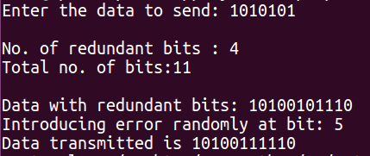

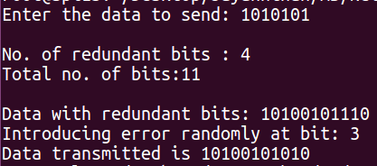

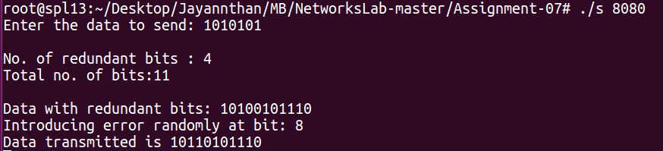

Client:

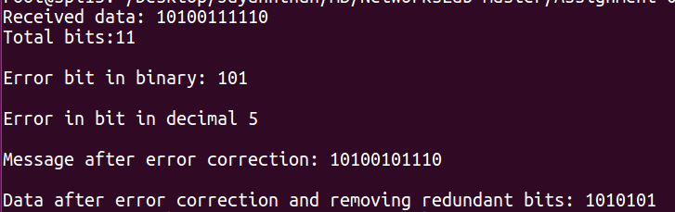

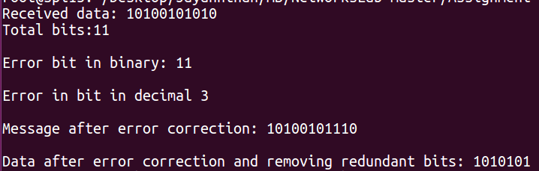

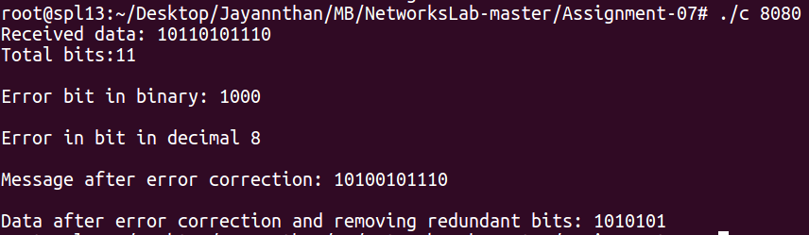

**Learning outcome:**

Learnt the working of hamming code error correction